【例4-61】用柱状图均等化增强对比
I = imread('tire.tif');
J = histeq(I);
imshow(I)
figure, imshow(J)
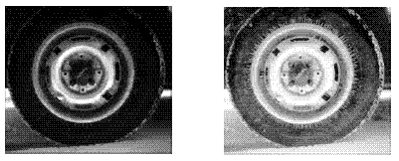
用柱状图均等化增强对比
imhist(I,64)
figure; imhist(J,64)
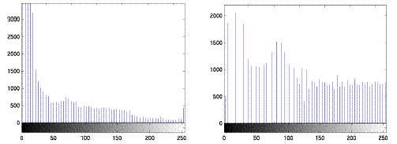
用柱状图均等化增强对比

